Opinion Polls

Poll No. 11

[Analysis of Results] | [Detailed Results] | [PDF Format ] | [باللغة العربية]

Summary of Results

Deteriorating living conditions:
The results of this poll reveal further deterioration in Palestinian living conditions in the last two years. For example, a majority declares that their family's monthly incomes are less than $420. This implies that 77% of the families have a daily income per person ranging between (10 Cents) and ($2.1).

Expect a better life for children:
A large segment of the respondents feel that their lives are worse than their parents, at the same time they expect a better life for their children.

Reliance on family kinship:
- The results reveal that Palestinians say that that are reliant on family institutions for personal protection and support. They also say that governmental institutions are important in case of need for education, health services, or in the event of serious crime.

- In reality however, United Nations Relief and Works Agency (UNRWA) constituted a critical support institution for the residents - especially in Gaza (due to the fact that about 75% of Gaza residents are refugees). Non - governmental organizations also played a major part in the delivery of assistance to the needy.

Concern with rising social problems:
Palestinians view monopoly and exaggerated prices of goods as very critical social problems. Violence and theft also alarmed them. Fear of corruption is also widespread.

Educational institutions are most trusted:
When asked to evaluate various institutions, schools, universities, and health institutions received the highest marks. The PNA, political groups, the opposition, and the Palestinian Legislative Council received the lowest ratings.

Reform as necessary:
In addition to ending the Occupation, respondents believe that reforming PNA institutions, local councils, NGOs, international donor organizations, and UNRWA is vital to the advancement of Palestinian society.

Detailed Analysis

1. Deteriorating Living Conditions

The results show deterioration in Palestinian living conditions:

- Over 82% say that their family's living conditions have deteriorated in the past two years. In contrast, 3% say that their conditions have improved. In addition, 15% say that there is no change.
- In excess of 77% of the respondents say that the income of their families is less than $420. This implies that 77% of the families have a daily income ranging between (10 Cents) and ($2.1) per person (in an average household - the average household size in the West Bank and Gaza is 6.5). About 18% say that the income of their families is between $420 and $840.
- About 50% described their family economic status as "bad or very bad" (a 10 point increase from February 2002). In addition, 37% say that their family economic status is (fair). Only 14% say that it is (good or very good).
- As to their expectations for the rest of this year, 41% expect further deterioration in their income, 21% expect improvement, while 30% expect no change.
- It was noticeable that West Bank respondents were more uncertain than Gazans about their incomes for the rest of the year. About 46% of West Bank respondents expect that their income will deteriorate, while 34% expect the same in Gaza.
- In terms of family disputes within the household, it is interesting to find that 33% of the respondents report an increase in the last two years. Only, 6% say that disputes have declined.
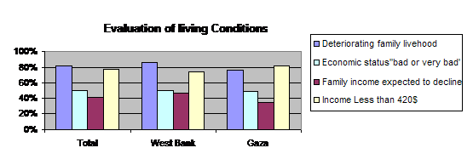
2. Views of the Past, the Present, and the Future

When asked to compare their living conditions with those of their parents:

- 44% say that their parents lived better. About 31% disagree, while 23% say that their living conditions are about the same as those of their parents.
- When asked about their expectations for how their children will live, 51% expected their children would live better than they live. This is compared with 24% who say that they expect that their children will be worse off. About 12% say that the lives of their children will be the same as their own lives.
- Regardless of these opinions, the majority of respondents hold to an optimistic view of the future, as 67% say that they are optimistic, compared with 33% who say that they are pessimistic.
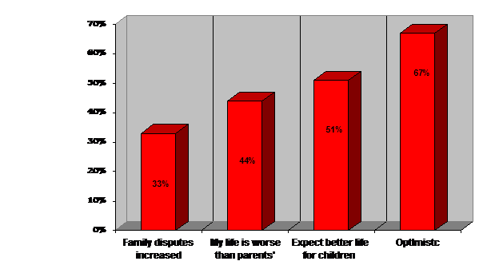

3. Sources of Support

Where would Palestinians go to for various types of support?

* Palestinians say that family kinship and other informal networks form important support networks especially with the declining role of governmental institutions.
* When asked where would they go to for support, 71% of the respondents say that they would go to their family in case they were part of a dispute with another family.
* In addition, 53% say that they would rely upon their families in case they were personally assaulted.
* Another 41% would go to their families to obtain financial assistance to meet their living needs.
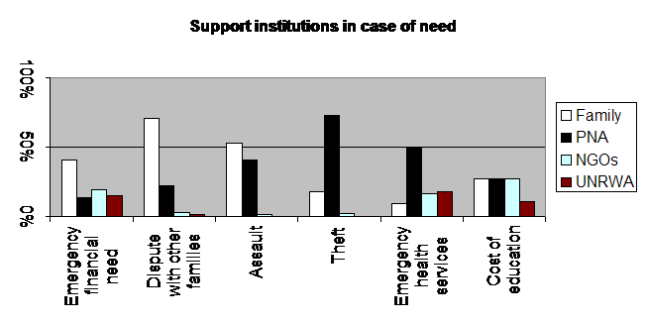
* In contrast, 73% would resort to governmental institutions in case their homes were exposed to burglary.
* Half of the respondents say that they would go governmental institutions for medical services.

4. UNRWA as a Primary Provider of Assistance

When respondents were asked to report which institution was the primary provider of assistance (cash or in - kind) during the past two years:

* From the total sample, 19% say that they received assistance from UNRWA.
* Another 16% received assistance from NGOs.
* About 10% from governmental institutions.
* In contrast, only 5% received assistance from family kinship.
* At the same time, 45% reported that they did not receive any assistance from any institution.

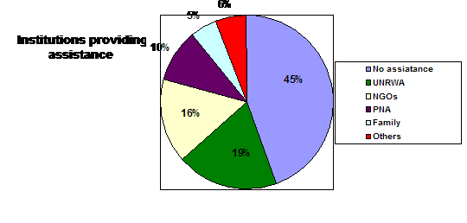
These data illustrate that, out of those who actually received assistance during the past two years:

* UNRWA was the primary provider for 34% of the households.
* NGOs were primary providers for 29% of the households.
* Government institutions were primary providers for 18% of the households.
* Family kinship was a primary provider in 8% of the cases.
* The rest (11%) reported other organizations.

A comparison between the West Bank and Gaza reveals stark differences:

* In general, 61% of Gaza respondents received assistance in the past two years, compared with 50% in the West Bank (probably due to higher poverty rates in Gaza).
* Data in the following table show that UNRWA plays a much more important role in Gaza compared with the West Bank concerning assistance provision, while governmental and non-governmental organizations play a more vital role in the West Bank than in Gaza (Table 1).

Table 1: Distribution of Recipients of Assistance in the West Ban and Gaza
 | West Bank | Gaza
UNRWA | 27% | 43%
NGOS | 31% | 26%
Government | 25% | 12%
Family kinship | 8% | 8%

4. Social Problems

Palestinians are mostly concerned with the following problems (the percentages in brackets represent those who say that these social problems are on the increase):

* Monopoly over goods and services (80%)
* Cheating by merchants (77%)
* Violence within society (75%)
* Traffic violations (75%)
* Theft (73%)
* Disputes among citizens (73%)
* Dropping out of schools (67%)
* Building violations (67%)
* Corruption in PNA institutions (66%)
* Divorce (65%)
* Early marriage (65%)
* Beating of children (62%)
* Beating of women (59%)
* Expired goods (56%)
* Taking over of others' lands (45%)

5. Evaluation of Institutions

Palestinians trust educational institutions the most. About 80% say that they trust (schools) and 76% say that they trust (universities). The least trust is in the PNA in general, the PLC, and political groups (as illustrated in the following Table).

Table 2: Trust in institutions (% of those who said that they are "trusting")
1. Schools | 80% | 8. Security agencies | 39%
2. Universities | 76% | 9. PNA ministries | 38%
3. Zakat Committees | 65% | 10. Women's unions | 37%
4. Government health services | 59% | 11. Workers' Unions | 35%
5. The Police | 47% | 12. Palestinian Opposition | 34%
6. Local media | 47% | 13. PLC | 34%
7. The Judiciary | 42% | 14. Political groups | 32%
 |  | 15. PNA | 32%

6. Reform

Palestinians were asked about what areas of reform are needed to advance Palestinian Society.

* No surprise, getting rid of Occupation came as the most important step, as 96% feel that that is necessary.
* In combination with that, 94% feel that reforming PNA institutions is necessary.
* A majority of respondents (about 88%) also mention reforming local councils and NGOs as necessary.
* A large majority (83%) feels that reforming the work of political groups is necessary.
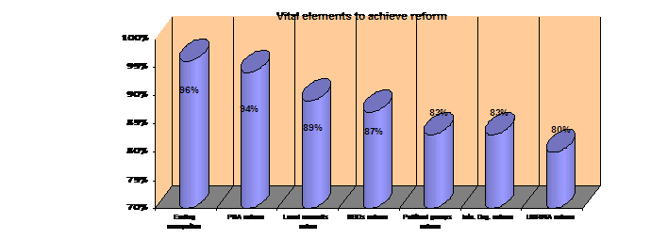
* Concern is also with international and donor institutions, as 83% feel that reforming the work of international donor institutions is necessary and 80% feel the same way about the work of UNRWA. In addition, 79% feel that the U.S.A. must reform its approach to the Palestinian issue for comprehensive reform to be feasible.

7. Political Affiliation

The data confirm a trend witnessed in the last two years: religious groups are gaining support and nationalist and leftist groups are losing. And while the survey results show that Fateh is still the largest political group, the collective weight of Islamist groups (Hamas, Jihad, and other supporters) is larger. The results also show that the educated (12 years of education or more) are more supportive of Fateh than the general public.
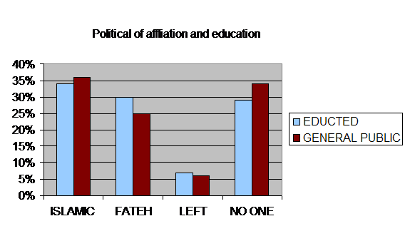

Top of this page | DSP Home

