Opinion Polls

Poll No. 10

Analysis of Results

[Analysis of Results] | [Detailed Results] | [PDF Format] | [باللغة العربية]

The Peace process
- A majority of the respondents (52%) supports the resumption of peace negotiations with Israel. Support is equally distributed between Gaza and the West Bank. In contrast, 46% oppose such negotiations at the present time.
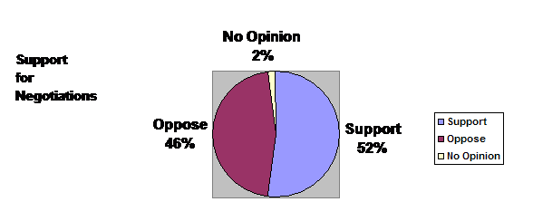

Armed attacks against Israelis
- A majority of Palestinians (69%) approves of a halt on armed attacks against Israelis residing in Israel. This is, however, conditional upon the ability of Palestinian political groups to reach an agreement amongst themselves on this issue. In addition, for 55%, it is conditional upon an Israeli halt on attacks against Palestinian civilians.

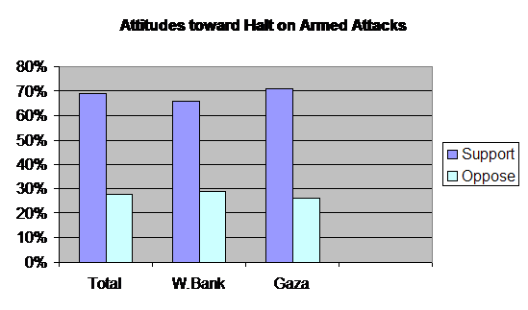
The Proposed Palestinian Constitution

1. Division over use of Islamic Sharia (Law):
Palestinians are divided on the use of Sharia as the "basis for legislation" in the proposed Palestinian Constitution; 38% see that Islamic Sharia' is the sole source of legislation. In contrast, 33% believe that human and civic rights must be the source of legislation. Another 29% see Islamic Sharia' as a primary source, but combined with human rights and international conventions. For 8% (out of this 29%) Sharia is acceptable as a primary source, but conditional upon the approval of an elected body.

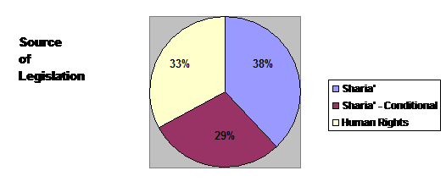
2. Sharia in governance might lead to abuse of power:
While many Palestinians feel that Sharia is an important element in their lives, many feel that the implementation of Sharia might not be "practical". About 54% feel that the use of Sharia in governance will lead to abuse of religion by the government only to reinforce its own power. Furthermore, the majority of respondents (76%) do not perceive the establishment of an Islamic state to be a realistic option.
3. Support for democracy:
It is also interesting to note that that over 66% of the respondents approve of an article stating that (the Palestinian political system is democratic, parliamentary, and based on political pluralism).
4. All Palestinians are born equal:
In addition, 92% approve on an article stating that (all Palestinians are equal before the law with equal rights and duties, and no discrimination will exit based on race, sex, color, religion, political opinion, or disability).
5. State must promote the status of women:
With regards to women's rights, a majority (82%) feels that the state must have an active role in eradicating obstacles that stand in the face of women's contribution to family and society in all fields.
6. Prime minister must be elected by parliament:
The majority of respondents (75%) say that the Parliament must elect the prime minister; only 16% feel that the president must select the prime minister after consultations with the Parliament.
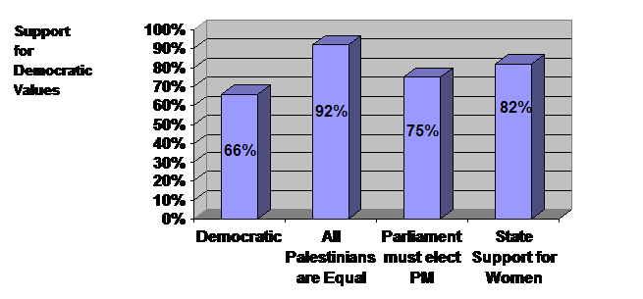
Elections
- Palestinian are divided about holding a presidential election, where 50% support such an idea and 48% oppose it.
- port for parliamentary elections is higher than presidential election, where 64% support such elections.
- Another majority (70%) supports local council election.
- At the same time, 70% support a reshuffle of the membership of the Palestinian National Council (a body of the PLO representing Palestinians all over the world).

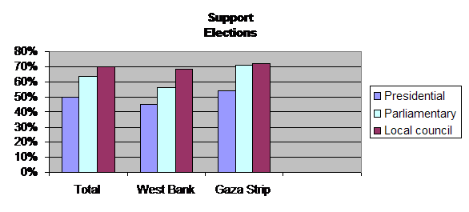
The Cairo Dialogue

- Most respondents do not expect much from the dialogue that is taking place in Cairo amongst Palestinian political groups. Only 44% believe that these groups will be able to reach an agreement amongst themselves. In contrast, 52% feel otherwise.
- And while a majority (69%) feels that these groups do no take the views of the public into account, they believe that they are into this dialogue to (achieve national interest). About 31% felt that they aim at achieving partisan interests.
- A large group of respondents (44%) feel that the PLO leadership must be the primary decision - making body. In contrast, 35% feel that the Palestinian National Authority's leadership must be the decision - maker. About 21% were not sure.
- About 90% of the respondents believe that it is necessary for all political groups to abide by decisions made by an elected Palestinian government.

Palestinian Political Groups
- Over 72% of respondents believe that Palestinian political groups do not implement democratic - transparent mechanisms in their internal party - related practices.
- Dissatisfaction with political groups is reflected in that fact that 51% of the respondents express that they do not support any of the existing political groups.
- Fateh received 24% support; Hamas received 14% and Islamic Jihad received less than 6%.
- When independents (comprising 51%) were asked to express their (leaning), they were divided as follows: about 15% with Islamic leaning; 6% with leaning to Fateh, and 2% with leftist leaning.
- Given these data, respondents might be divided as follows: Islamic support or leaning (34%); Fateh support or leaning (30%); leftists support or leaning (7%); support for no one (29%).
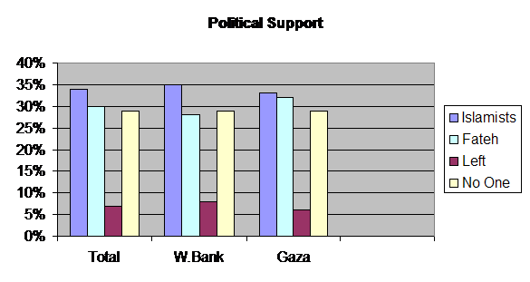

In conclusion the results show that there is a majority support for some propositions, while there is a split over others (as illustrated in the following table).
Majority | Split
- Halting attacks inside Israel  - Democratic, parliamentary, pluralistic system  - Holding parliamentary and local council elections  - Restructuring the Palestinian National Council  - Palestinian political groups do no take views of public into account  - Palestinian political groups are not transparent internally  - A role for the state in promoting women's rights | - Resumption of negotiations  - Source or basis for legislation  - Holding Presidential elections  - Confidence in the Cairo Dialogue  - Body responsible for decision - making  - Political affiliation

Top of this page | DSP Home

