Opinion Polls
Poll No. 17

An Opinion Poll Concerning the Performance of Palestinian Institutions, their Service Provision, their Role in the Development Process, and International Funding

[ Analysis of Results ] [ Detailed Results ] [ Sample Distribution ] [ PDF Format ] [ In Arabic ]

Analysis of Results

Part One: Trust in Palestinian Institutions:
Level of Trust in Palestinian and International Institutions
- Respondents reported a high level of trust in Palestinian service providers (health, education and civil defense). At the same time, the majority has expressed a lack of trust in PNA institutions, the Palestinian Legislative Council, as well as the various political groups.
- The level of trust in other Palestinian organizations is as follows: Al-Zakat Committees (58%), the local media (50%), civil society institutions and charities (47%).
- The majority of respondents (53%) have trust in UNRWA.
- Results show that Traditional conciliation councils enjoy a higher level of trust (57%) than the Palestinian justice system (43%).
- Generally speaking, there appears to be a higher level of trust among Gaza respondents than respondents from the West Bank.
Table (1): Level of Trust in Palestinian and International Institutions
 | Total (%) | West Bank (%) | Gaza Strip (%)
1. Schools | 82.4 | 78.8 | 88.0
2. Palestinian Universities | 61.7 | 62.3 | 60.7
3. PNA Health Provision | 60.6 | 54.5 | 70.2
4. Civil Defense | 58.9 | 55.9 | 63.5
5. Zakat Committees | 58.0 | 54.0 | 64.3
6. Traditional conciliation councils | 57.1 | 53.1 | 63.2
7. UNRWA | 53.4 | 46.6 | 63.8
8. Local Media | 50.4 | 48.5 | 53.4
9. Civil Societies and Charities | 47.4 | 44.4 | 52.2
10. Justice System | 42.5 | 39.9 | 46.4
11. Women’s Committees and Unions | 37.7 | 35.0 | 42.0
12. Palestinian Police | 37.2 | 34.3 | 41.6
13. Funding Agencies | 36.7 | 30.8 | 45.9
14. Labour Unions | 36.2 | 31.4 | 43.8
15. Palestinian Opposition | 35.9 | 35.6 | 36.5
16. Security Forces | 31.9 | 29.5 | 35.6
17. Other Palestinian Institutions | 31.2 | 29.9 | 33.3
18. Palestinian Legislative Council | 27.8 | 28.7 | 26.4
19. Political Groups | 26.6 | 27.9 | 26.4
Part Two: Evaluation of the performance of Palestinian Institutions
The results show differing opinions among respondents regarding the performance of Palestinian Civil Society Institutions, as well as suspicions regarding the conduct and role of PNA and Private Sector Institutions.
- The conduct of the PNA in light of currently available opportunities
Results from the poll point to differing opinions among respondents regarding the performance of the PNA and its institutions in relation to the economic, social and security requirements of the Palestinian people.
1. Everyday Needs: 12% of respondents believe that the PNA is fully capable of meeting their needs. 26% thought it was capable to a certain extent, while the majority (58%) believe that the PNA is incapable of meeting the everyday needs of Palestinians.
On a related issue, only 14% of respondents believe that the PNA provides assistance to the poor, and 22% thought that it provided assistance to a certain extent. However, a big majority (57%) believe that it does not provide any assistance to the poor.
2. Social Issues: In relation to how the PNA deals with important social issues, there appears to be a three-way split in opinions relating to the extent to which the PNA resolves disputes among citizens. 33% believe that the PNA engages in resolving disputes, while 31% believe it does so to a certain extent and 31% saying that it does not do so at all.
On the issue of whether the PNA treats all citizens equally, 18% of respondents believe that it does, 17% believe that it does so to a certain extent, and a further 59% believe that it does not.
3. Individual Security and the Rule of Law: 33% of respondents believe that the PNA is fulfilling its duty in providing security for the individual, while 29% believe that it is fulfilling its duty to a certain extent. However, a slim majority (35%) believe that the PNA fails in this regard. With regard to the rule of law, a clear majority of respondents (42%) believe that the PNA is incapable of enforcing the rule of law, while 30% believe that it is fully capable and 24% believe that it is capable to a certain extent.
4. Corruption and the Misuse of Public Funds: A clear majority of respondents (57%) have expressed doubts that the PNA is doing enough in the fight against corruption in PNA institutions.
5. The Future of the PNA: Respondents are generally concerned about the lack of clarity regarding the future role of the PNA. 44% have expressed their concern its future, while 43% believe that it no longer enjoys a high level of standing in the Palestinian street.
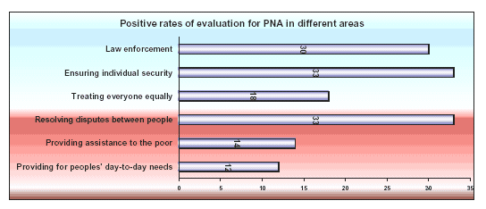
- Performance of Entrepreneurs and the Private Sector
1. A huge majority (62%) of respondents thought that entrepreneurs and the private sector in general do not play a big enough part in tackling the country's economic problems. Only 12% believed that they did, 21% believed that they did to a certain extent.
2. On a related issue, the vast majority (61%) of respondents believe that the private sector does not treat all its employees equally. Only 11% believe that the private sector treats its employees fairly, while 22% believe that it does so to a certain extent.
- The performance of Palestinian Civil Society Institutions, Charitable Organizations, and Political Groups
In relation to the performance of Palestinian civil society institutions, charitable organizations and political groups, the results obtained are as follows: -
1. A slim majority (38%) of respondents believe that civil society institutions and charitable organizations are fulfilling their duties towards the Palestinian people. 36% believe this to be the case to a certain extent, while 21% believe that these organizations are failing in their duties towards the Palestinian people.
2. There appears to be a three-way split regarding the extent to which Palestinian political groups are playing their part in offering solutions to social and political problems. The majority (34%) of respondents are satisfied that this is the case, while 27% are satisfied to a certain extent, and 28% are not satisfied at all.
- Evaluation of the role and effectiveness of service provision in the current period:
1. There appears to be a rising level of trust among respondents in the education system, coupled with rising satisfaction rates with the type and effectiveness of education provision. 64% consider education provision to be of a good standard, while 28% believe it is good to a certain extent, and a minority (6%) considers it to be bad.
2. A clear majority of respondents (49%) expressed satisfaction with refuse collection services and general cleanliness, while 29% thought it was fair and 21% thought it was unsatisfactory.
3. A clear majority (48%) of respondents thought that the level of healthcare provision was good, while 37% described it as fair, and only 13% thought it was unsatisfactory.
4. With regard to the service provision of governmental departments, there appears to be a two-way split between those respondents who expressed satisfaction (39%) and those who expressed satisfaction to a certain extent (39%). Only 17% of respondents were dissatisfied with their service.
5. On the issue of traffic control, 31% of respondents are satisfied with the service, 26% see it as good to a certain extent, while a majority (39%) considers it to be bad.
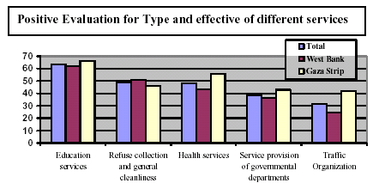
Part Three: Palestinian Views Concerning the Role of Institutions in the Development Process
The majority of respondents believe that Palestinian Civil Society Institutions are playing their part in the development process and help foster popular participation. Respondents are less generous in their evaluation of PNA institutions.
Table (2): Palestinian views about the role of PNA and civil society institutions in the development process
 | PNA (%) |  |  | Civil society (%)
 | Total | West Bank | Gaza Strip | Total | West Bank | Gaza Strip
Building and empowerment Palestinian Society | 47.2 | 44.4 | 51.4 | 55.3 | 52.2 | 60.1
Encouragement popular participation | 33.5 | 35.9 | 34.9 | 48.5 | 44.8 | 54.2
Developing Palestinian Society | 41.3 | 40.4 | 42.8 | 48.9 | 45.2 | 54.8
Part Four: Assessment of the Current Palestinian Government
- A mixed opinion regarding the performance of Ahmad Qurei's government, particularly in view of the fact that it does not appear to have a clear strategy.
- A feeling that the government should be replaced.
- A slight majority of respondents (33%) believe that the performance of Ahmad Qurei has been weak, 31% believe it has been fair, and 26% believe it has been good.
- With regard to the performance of Mr. Qurei's government, 22% think it has been good, 32% fair, and 36% believe it has been weak.
- A clear majority of respondents (51%) believe it is necessary to replace the current Palestinian government with a new government, whereas 36% believe that the current government should not be replaced.
- An overwhelming majority (40%) of respondents believe that the current Palestinian government does not have a clear strategy for addressing the concerns of the Palestinian people. Only 19% believe otherwise.
Part Five: International Aid
There have been mixed opinions regarding the issue of international aid. Whilst respondents believe that international aid is helping to lessen the suffering of the Palestinian people, they also see it as being granted in accordance with a certain political agenda. What's more, they believe it consolidates Israel's control over the occupied Palestinian territories.
- A slim majority (39%) of all respondents believe that international assistance has contributed to Palestine's social development. 38% believe that it has contributed to a certain extent, whereas 21% believe that it has not contributed at all.
- On this same issue, 49% of respondents believe that international assistance has lessened the human suffering of the Palestinian people. A slightly higher proportion (56%) of Gaza respondents believes this to be the case than in the case of West Bank respondents (44%).
- A clear majority (55%) of all respondents believe that international assistance has consolidated Israel's control over the occupied Palestinian territories. Only 32% believe that it has served the long-term interests of the Palestinian people.
- There appears to be a two-way split between those respondents (45%) who believe that international aid has worked against the rights of Palestinian refugees, and those (45%) who believe that it has served to reinforce those rights. It is worth noting that there is a clear difference in the responses of West Bank and Gaza respondents. 49% of West Bank respondents and 39% Gaza respondents believe that international aid has worked against the rights of Palestinian refugees, while 39% of West Bank respondents and 55% of Gaza respondents believe that it has served to reinforce those rights.
- The overwhelming majority (62%) of respondents believe that donor countries and funding agencies have a hidden political agenda when it comes to the granting of international financial aid to the Palestinians. Only a small minority of respondents (14%) believe that the international donor community acts solely out of concern for the needs of the Palestinian people. 24% of respondents believe that both issues are at play when the international donor community grants financial assistance to the Palestinians.
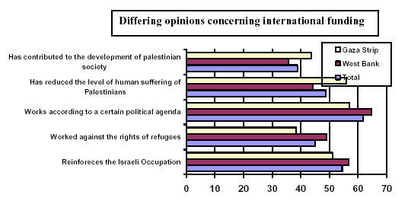
- Funding Priorities: Given the high level of unemployment in the Palestinian Territories, it is clear that the main concern of Palestinians is finding job opportunities. 48% of all respondents believe that donor countries should concentrate their aid efforts in this sphere. A further 24% believe that international assistance should concentrate on strengthening Palestinian infrastructure. Other priorities include relief efforts (11%), building and strengthening social institutions (8%), building and strengthening the manufacturing sector (6%), and widening popular participation and consolidating democracy (4%).
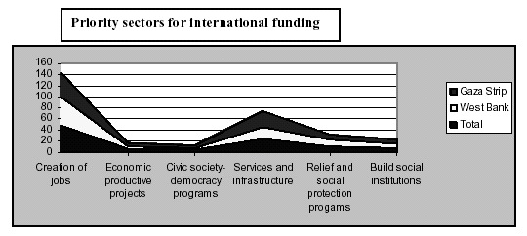
- Direct Benefits from international financial assistance: The vast majority (78%) of our respondents have said that they or their families have not benefited directly from the assistance provided by the international donor community, as opposed to 22% who said that they had. 82% of West Bank respondents have not benefited directly from international financial assistance. For the Gaza Strip, this figure was 70%.
- Of those who benefited directly from such assistance, 54% said that the assistance was in the form of social care, as well as relief and emergency aid. A further 21% benefited from job creation schemes, 10% from infrastructure projects and 4% from training courses aimed at enhancing their role in society.
- Who should be in receipt of future international donor aid?: 56% of all respondents believe that all future international donor aid should go directly to Palestinian civil society institutions, while 24% thought it should go to PNA institutions. A further 20% believe that all future aid should be ploughed into the private sector. These responses relate directly to the increasing level of trust in civil society institutions and decreasing trust in the PNA and private sector institutions.
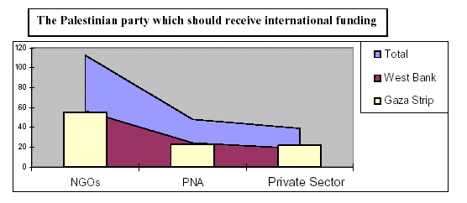
Top of this page | DSP Home

