Opinion Polls
Poll No. 16

Public Opinion Poll on Palestinian Living Conditions, the Peace Process, Rafah Operation and Sharon's Proposed Disengagement Plan

[ Information & General Background ] [ Analysis of Results ] [ Detailed Results ] [ Sample Distribution ] [ PDF Format ] [ In Arabic ]

Analysis of Results
Part One: Palestinian Living Conditions
The survey results indicate that the economic situation of citizens is still deteriorating:
- A minority of respondents described their economic situation as 'good' or 'very good' (22%). 41% described it as 'medium', while 38% described is as 'bad' or 'very bad' (41% in Gaza and 36% in the West Bank).
- Respondent Palestinian households whose heads are unemployed account for 35%. This percentage is 6.6 points up on what it was in October 2003.
- Results also show deteriorating income levels for the vast majority of Gaza residents. 39% of respondent households reported their monthly income as being less than 700 shekels (equivalent to $157). The income of 65% of the households is less than 1700 shekels ($382). 6% do not have any income. It is worth noting that the poverty line for a household of six members is 1641 shekels ($362).
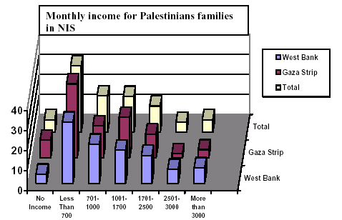
Results of the poll indicate that citizens have feelings of insecurity:
- The majority (61%) of the respondents have feelings of insecurity towards their households and property whereas 17% reported that they have feelings of security.
- The results show differing levels of optimism among respondents. 39% are optimistic about the future, 23% look at the future with both optimism and pessimism and 37% are pessimistic about the future. Results show that there are differences between the respondents in the West Bank and those in the Gaza Strip: 41% of the West Bank respondents are pessimistic (this percentage is 10% higher among respondents in Gaza).
Part Two: Evaluation of the performance of various organizations in the wake of the Israeli incursion on Rafah which started on 18th May 2004
- High confidence in the performance of the civil society organizations, political parties and factions and UNRWA, doubt regarding the performance of the PNA organizations and a mixed attitude towards the UN resolution concerning Rafah events.
- A good majority of Gaza residents appear to be disappointed with the PNA's performance in the wake Israel's operation in Rafah. 22% of the respondents evaluated the performance of the PNA regarding the recent events in Rafah as positive, 33% as medium and 40% of the respondents said that the PNA performance had been negative.
- Palestinian Civil Society Institutions fare much better among respondents than the PNA. 46% of respondents evaluated the performance of civil society organizations in the wake of recent events in Rafah as positive, 31% as medium and 17% as negative. Evaluation of political parties and factions has been close to the performance of civil society organizations: positive 44%, medium 29% and negative 18%.
- The United Nations Relief and Works Agency (UNRWA) and its performance in the wake of the Israeli incursion is also seen in good light among our respondents. 47% evaluated the UNRWA performance as positive, 29% as medium and 15% as negative.
- A large majority of respondents (34%) reported that the international attitude towards the Rafah events is positive, 8% considered it as negative and 22% considered it as in between.
- All the organizations obtained higher rates of evaluation among respondents in the Gaza Strip than among the West bank respondents.
Part Three: Sharon's Proposed Disengagement Plan
- Although suspicious about the intentions of Sharon and his government, respondents believe that there is a high willingness and preparedness among the various Palestinian parties in the Gaza Strip to take part in Gaza's administration. In contrast, there is reservation towards any American role in Gaza after an Israeli withdrawal.
- The majority of respondents (53%) believe that Sharon is not serious about his withdrawal from the Gaza Strip.
- If Israel does eventually withdraw from the Gaza Strip, 50% of the respondents believe that it will be partial; only 11% believe that it will be complete. Another 38% believe that there will not be any withdrawal at all. There is a marked difference between the views of West Bank respondents and those in the Gaza Strip. While 55% of Gaza respondents believe that the withdrawal will be partial, 47% of the West Bank respondents believe the same and while 41% of the West Bank respondents believe that there is not going to be any withdrawal from Gaza Strip, 34% of Gaza Strip respondents have the same belief.
- PNA and withdrawal from Gaza Strip
- 39% of the respondents believe that the PNA is fully prepared for running the Gaza Strip, 31% believe that it is prepared to a certain extent and 25% of the respondents believe that it is unprepared for the task.
- 34% of the respondents believe that their living conditions will improve when the PNA takes over the day-to-day running of the Gaza Strip. In comparison, 29% believe that that will not improve their conditions, while 33% believe that their conditions will improve to a certain extent.
- Background to withdrawal plan from the Gaza Strip
- 77% of the respondents believe that the proposed Israeli withdrawal from Gaza is to avoid more considerable losses among the Israeli occupation forces.
- 78% of the respondents (83% in Gaza Strip compared to 73% in the West Bank) believe that the withdrawal plan from Gaza will be at the expense of worsening occupation in the West Bank.
- 57% of the respondents believe that withdrawal from the Gaza Strip will bring chaos and internal fighting. Asked if the respondents believed that the Palestinian political parties and factions are likely to succeed in avoiding internal fighting, 64% of them reported that they will.
- The Political future of the Gaza Strip after the proposed Israeli withdrawal
- 37% of the respondents believe that the PNA has a program and a comprehensive plan for the administration of the Gaza Strip after the Israeli withdrawal while 36% believe that the PNA has a program and a plan to a certain extent and 20% believe that the PNA does not have a plan at all.
- 42% of the respondents believe that the PNA does not have a political program for confronting Sharon's plans while 25% believe that it has this program and 25% believe that it has this program to a certain extent.
- 28% of the respondents see that the Palestinian opposition does not have a political program for confronting Sharon's plans while 35% reported that it has and 27% believe that it has to a certain extent.
- The majority (61%) of the respondents support the continuation of the armed resistance from Gaza strip against Israel after it withdraws whereas 35% are opposed.
- 84% of the respondents support the necessity of unifying the security apparatuses into one security apparatus in the event of an Israeli withdrawal from the Gaza strip.
- Also, 84% of respondents (89% of the respondents in the Gaza Strip compared to 81% in the West Bank) believe that it is necessary to immediately conduct legislative elections in Gaza in the event of an Israeli withdrawal from it.
- Asked about the most suitable leadership structure of the Gaza Strip after an Israeli withdrawal, 59% of the respondents believe that the most suitable would be a unified national leadership including all the parties (63% in the West Bank and 56% in Gaza strip), 23% reported that the PNA would be the most suitable. This figure was 17% for Hamas and Islamic Jihad (20% in the West Bank and 11% in Gaza strip).
- Reconstruction of the Gaza Strip
- 45% of the respondents believe that the Gaza Strip is likely to be a prosperous place after an Israeli withdrawal, while 34% see this possibility to a certain extent and 18% do not see such a possibility.
- 39% of respondents believe that the top priority after withdrawal is achievement of security and safety, whereas 28% declared that priority is for the reconstruction of the destroyed areas.
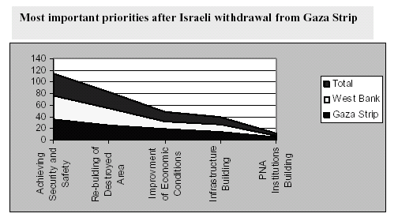
- Asked what should happen to the Israeli settlements after they are evacuated, 41% of the respondents believe they should be used to house returning refugees whereas 32% support their transformation for the inhabitants of the camps in Gaza Strip. It seems obvious that transforming the settlements into investment areas is a higher priority among Gaza Strip respondents than among West Bank respondents.
Table 1: Purposes to which respondents support the transformation of the settlements to in case of their evacuation
 | Palestinian territories | West Bank | Gaza Strip
Allocate them for returning refugees | 40.8 | 45.0 | 34.2
Housing units for Gaza Strip refugees | 32.4 | 35.5 | 27.7
Investment zones (tourist and industrial) | 11.0 | 6.1 | 18.6
Transform them into public buildings | 4.2 | 4.0 | 4.5
Housing units for PNA employees | 3.9 | 4.7 | 2.6
Others | 7.7 | 4.7 | 12.4
- Financing of Gaza Strip reconstruction
- 70% of the respondents oppose any American role in the financing the reconstruction of the Gaza Strip in the event of an Israeli withdrawal from it, while 28% are supportive of an American role.
- The majority of the respondents support financing by different parties as follows: Arab countries (87%), Japan and other Asian countries (73%), European countries (68%) and UN financing (78%).
- Findings point out that there is higher support among respondents in Gaza Strip for financing from different sources than among respondents in the West Bank (see table 2).
Table 2: Percentages of respondents supporting financing by different parties in Gaza Strip reconstruction
 | Palestinian territories | West Bank | Gaza Strip
Arab financing | 87.1 | 84.9 | 90.5
Japanese and Asian countries financing | 73.2 | 69.6 | 78.9
European financing | 68.4 | 66.3 | 71.7
UN financing | 68.3 | 64.2 | 74.7
American financing | 27.8 | 25.0 | 32.3
- Role of various parties in Gaza's administration
- 85% of the respondents oppose any provisional role for the United States in the administration of the Gaza Strip after the Israeli withdrawal while 13% support such a role.
- In the same context, the majority of the respondents support an effective role for each of the World Bank (57%), Arab league (56%), and UN (55%) in a provisional administration for Gaza strip after the Israeli withdrawal. In addition, 45% support a role for Egypt and 40% support a role for the European Union. Rates of supporters for efficient roles for different parties in the administration of the Gaza Strip for a provisional period after withdrawal
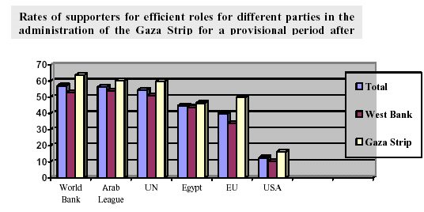
Part Four: Peace process and the Arab Summit
General frustration among the Palestinians towards the possibilities of achieving Palestinian-Israeli peace accompanied by high suspicion about the intentions of Israel and the United States concerning achieving peace for the Palestinians. The Palestinian street is still betting on the importance of demonstrations carried out by Israeli peace movements against the occupation policy of Israel in comparison with the negative attitude of the Arab street and Summit towards the Palestinian cause. Nevertheless, respondents generally support the sponsorship of the Arab League for the Palestinian-Israeli peace process.
- Absence of confidence in the American role in the peace process: 87% of respondents said that they do not believe that the United States is serious about achieving peace in the Middle East. Only 7% of respondents believe otherwise.
- Low support for negotiations: The majority of respondents (52%) expressed their opposition for a return to negotiations with Israel, whereas 45% indicated their support for such a move. It is worth noting here that support rates for a return to negotiations with the Israelis have dropped by 16 percentage points in comparison with October 2003 polls (61%).
- Israel is not willing to achieve peace with the Palestinians: The poll's findings indicate that 88% of the Palestinian public believe that Israel has no real willingness to achieve peace with the Palestinians.
- Solving the refugee issue is the foundation of any peace agreement: The majority (84%) expressed that peace is impossible between Palestinians and Israelis if Israel does not recognize the right of Palestinian refugees to return, whereas only 13% believe that there is possibility for peace between the two sides even in he event that Israel does not recognize the right of refugees to return to their homes.
- Difficulties in co-existence between Palestinians and Israelis: The majority of respondents (54%) doubt the possibility of co-existence, side by side, between Palestinians and Israelis within the framework of a peace treaty. 38% believe otherwise.
- The Arab League is the most acceptable party to sponsor the peace process: The extent to which the Palestinian public prefers various parties to sponsor the peace process is as follows: Arab League (51%), United Nations (25%), United States (5%) and other parties (14%).
- Reliance on the Israeli peace movement: The survey findings show that the Palestinians still believe in the importance of demonstrations carried out by Israeli peace movement; 52% of the respondents believe in their importance, 23% consider them important to a certain extent, whereas 22% do not see any importance for such demonstrations.
- A negative attitude to the official Arab role: While the majority (79%) of the respondents negatively evaluated the Arab Summit results, 24% of the Palestinians evaluated the role of the Arab people as positive, 32% as in between and 41% as negative.
Part Five: Political trends
- Unprecedented support for the Islamic movements in comparison with other national factions; while support for the Islamic movements reached 37%, the support for PLO factions together reached 31%.
- 42% of the respondents expressed their non-support for any of the political factions on the Palestinian arena.
- 22.6% of the respondents expressed their support for Fateh, 4.1% of the respondents expressed their support for the Palestinian leftist factions, 24.8% support Hamas and 4.9% of the respondents support the Islamic Jihad.
- Asking the independents (42%) about their tendencies for any of the above- mentioned political trends, 7.6% of them expressed their tendency towards the Islamic movements compared to 3.1% for Fateh.
- The Palestinian street, at the time of the poll, was divided as follows: 37.0% for Islamic movements, 25.7% for Fateh, 4.3% for the leftist factions and 31.3% do not support any of the political groups.
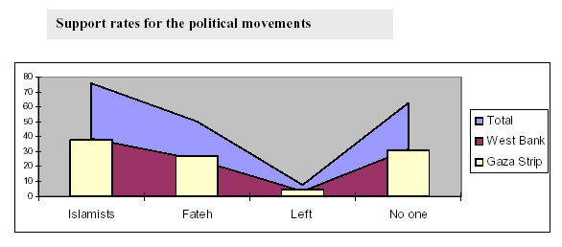
- Arafat is the most popular Palestinian personality
- Asked about the person they believe is best placed to lead the Palestinian people in the period after the Israeli withdrawal from Gaza, the results are as follows: Yasser Arafat (33%), Marwan Barghouthi (3.6%), Mohammad Dahlan (2.6%), Ahmad Qurei (2.3%). 11% of the respondents nominated prominent leaders in the Islamic movements for that role. Among such personalities are Ismail Hania (Hamas, 4.5%), Mahmoud Al-Zahar (Hamas, 3.7%). 5% of the respondents nominated leftist and independent personalities such as Haidar Abdel Shafi (2.5%).
- 37% of the respondents have not identified any Palestinian personality they trust to lead the Palestinian people in the period after the proposed Israeli withdrawal from Gaza Strip.
- The question in popularity was an open-ended question. This is not the same as saying "who would you elect?".
Top of this page | DSP Home

