Opinion Polls

Poll No. 13

[Analysis of Results] | [Detailed Results] | [PDF Format] | [باللغة العربية]

Section 1: Background

- On the 4th of July, Mahmoud Abbas, Ariel Sharon and George W. Bush held an historic meeting in Aqaba, Jordan to launch the Road Map, a peace plan intended to help the Palestinians and Israelis achieve independent, peaceful co-existence.
- A majority of Palestinian factions agreed to a “Hudna” or ceasefire at the end of June, halting attacks against Israeli targets. Thus far, all factions have honored the agreement.
- A debate exists amongst Palestinians as to an extension of the ceasefire by an additional 3 months.
- Living conditions continue to remain severely deteriorated with more than 41% of households without any source of income, and most Palestinian cities remain under closure.
- Despite Israeli claims that they have dismantled major checkpoints at Qalandia (Ramallah), Hewara (Nablus) and Al Hamra (primary entry point to northern cities of the West Bank), these remain intact, while smaller nearby checkpoints have been converted from permanent checkpoints to those with mobile military units acting as checkpoints, stationed in the same locations.
Section 2: Analysis of Results

1. Living Conditions

The following results show that no improvement has taken place in Palestinian living conditions since the implementation of the Road Map (launched about two months ago) and the inauguration of the new Palestinian Government (inaugurated three months ago).

- 41% of households have no working breadwinner (no change since May 2003).
- 38% of the respondents described their economic conditions as (bad) or (very bad). In addition, 44% described their economic conditions as (fair). In contrast, only 18% described their conditions as (good) or (very good).
- Regardless of these deteriorating living conditions, most Palestinians are still hopeful for the future. About 42% say they are optimistic and 25% say they are pessimistic. 32% have mixed feelings.

2. Mixed feelings about the Performance of the new government

The majority of respondents realize there are obstacles faced by the new Palestinian Government headed by Mr. Mahmoud Abbas. About 79% said that Israel is placing obstacles in the face of the new government leading to low rates of success in its performance. Another 56% said that there are internal obstacles that are hindering the performance of the new government. An additional 36% said that the new government has no (power) to implement its programs. At the same time, 36% said that it has (some power); while 22% said that it has (enough power).

Having said this, respondents expressed mixed levels of evaluation of the new government:

- 27% evaluated the performance of Prime Minister Mahmoud Abbas as (good), and 34% said it was (fair). At the same time, 28% said that his performance was (weak).
- As to the performance of the new ministerial cabinet, 23% said that it was (Good), and 39% said that it was (fair). In contrast, 31% said that the performance of the new cabinet was (weak).
- Doubts about the performance of the new cabinet and its prime minister are higher in the West Bank than in Gaza. One third of the West Bank respondents said that the performance of the new cabinet was (weak), compared with 28% among Gaza respondents.
- When asked to evaluate the performance of the new government in specific fields, the picture became more complicated. The new government received it lowest marks in the fields of alleviating unemployment, getting the Israelis to withdraw from Palestinian cities and lift the closure, and fighting corruption. In contrast, the new government received relatively higher marks in the fields of improving governmental services and improving the rule of law (see table 1). As the table also shows, West bank respondents were more critical of the new government than Gaza respondents.
Table (1): Percentage of respondents who evaluated the performance of the new government as (Weak) according to region
Field | West Bank | Gaza | Total
Reducing unemployment | 68.7 | 54.5 | 63.6
Withdrawal of Israeli forces | 63.7 | 56.9 | 61.3
Lifting of the closure | 68.1 | 46.3 | 60.3
Fighting corruption | 55.6 | 46.2 | 52.2
Resolving the problem of illegal weapons | 50.3 | 49.3 | 49.9
Improving economic conditions | 53.4 | 40.7 | 48.8
Providing security for citizens | 53.8 | 29.0 | 44.9
Progressing in negotiations with Israel | 42.5 | 49.0 | 44.8
Mobilization of the Judiciary | 44.6 | 27.6 | 38.6
Reinforcing the rule of law | 42.6 | 30.1 | 38.1
Improving governmental services | 38.5 | 25.7 | 33.9

A May, 2003 DSP poll showed that 51% of respondents expected the new government to improve living conditions, and 60% said that it would improve the performance of governmental institutions. In addition, 47% expected that it would be able to fight corruption.

3. Halt on attacks against Israeli targets

While a majority of Palestinians is supportive of a truce, where Palestinian factions stop attacks on Israeli targets for three months, they are doubtful that Israel will abide by any agreement.

Results show that 74% support the truce agreement by most Palestinian factions. Support for a truce in Gaza (80%) was higher than in the West Bank (71%).
- 61% approves of a renewal of the truce for another three months, with 66% in Gaza and 59% in the West Bank. One third of the respondents oppose any renewal of the truce.
- 75% feel that the factions must abide by the truce agreement.
- This is despite the fact that 77% believe that Israel will not abide the truce agreement.
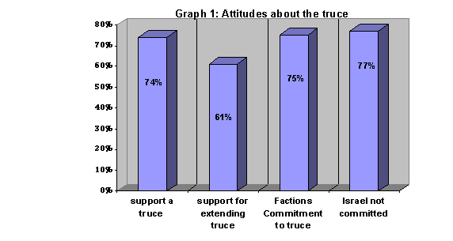

4. Elections

A majority supports the conduct of an election in the near future. The same majority intends to participate.

- 74% support a legislative council election and 73% support local elections. Support for presidential elections is 61%.
- 77% will participate if elections take place, 19% will not participate.
- If the opposition calls for a boycott, 57% intend to participate and 29% will boycott.
- 65% intend to register for the elections.
- While at the same time, 65% said that they do no have sufficient information on how to register.
- Future elections promise a significant turnover of elected officials; 55% say that they will vote for new candidates for the legislative council and only 16% intend to re-elect the current representatives. The same applies to current members of local councils, where about 19% said that they will vote for incumbents, and 57% said they will elect new candidates.
- Honesty and a role in serving the community are the most important criteria identified as desirable candidate traits by respondents, followed by educational attainment and religiosity. Respondents say that the role in the struggle, party membership and familial relationships will not play major role in their selection of a candidate (see table with complete results).

Table (2): Percentage of Respondents stating that the following characteristics are important or very important when voting for a candidate
 | West Bank | Gaza | Total
1) Honesty | 98.5 | 98.6 | 98.5
2) Role in serving community | 96.7 | 97.9 | 97.1
3) Educational attainment | 95.0 | 94.5 | 95.2
4) Religiosity | 85.5 | 88.1 | 86.5
5) Role in the struggle | 82.1 | 83.2 | 82.6
6) Political affiliation | 40.8 | 31.2 | 37.3
7) Family ties | 26.0 | 24.0 | 25.2

- Respondents further identified honesty and transparency, commitment to the rule of law and ability to resolve social problems as the most important characteristics that President of the country must possess, followed closely by the ability to face challenges emanating from the Israeli Occupation, commitment to religious values and commitment to democracy.

Table (3): Percentage of Respondents stating that the following characteristics are important or very important when voting for a future president
 | West Bank | Gaza | Total
Honesty | 98.8 | 99.1 | 98.8
Committed to the rule of law | 96.8 | 98.4 | 97.3
Able to resolve social problems | 96.2 | 94.8 | 95.7
Able to end the Occupation | 95.3 | 94.8 | 95.2
Possesses international diplomacy skills | 95.0 | 94.2 | 94.7
Committed to Islamic values | 93.1 | 97.1 | 94.5
Possesses global awareness | 90.6 | 89.0 | 90.0
Possesses a college degree | 88.9 | 91.8 | 89.9
Able to achieve democracy | 87.2 | 86.8 | 87.1
Possesses military experience | 87.9 | 85.6 | 87.0
Active in the national struggle | 78.3 | 84.7 | 80.6

5. Political affiliation

The political scene has experienced drastic changes since the start of the second Palestinian Intifada and the re-occupation of most West Bank and Gaza lands by Israel. In 1996, support for Islamic groups did not exceed 20%, while support for Fateh was over 45%. The current poll confirms a rise in support for (Islamist) groups and (independents), and decline in support for nationalist and leftist groups:

- 44% expressed no support for any existing political party or faction. This is an increase from about 30% in 1996.
- 26% expressed support for Fateh (the main nationalist faction headed by President Yasser Arafat). A little over 6% expressed support for all leftist groups listed in the poll. Of these groups, the Popular Front for the Liberation of Palestine (PFLP) receives the most votes (2.6%). At the same time, about 18% expressed support for Hamas and about 6.5% for Islamic Jihad.
- When independents were asked to select the party they sympathize with the most, 7.2% said that they sympathize with an Islamic faction. Very few expressed sympathy with nationalist or leftist groups.
- This had an impact on the voting patterns of the respondents. When asked to vote for one of the listed parties in an upcoming election, votes for all parties (especially Hamas) exceeded the percentage of declared support as expressed in the previous question.
- If they were to vote according to party lists, respondents made the following choices: Islamists (32.5%), Fateh (29.6%), and leftists (7.6%). Still one third would not vote for any of the parties listed in the poll.
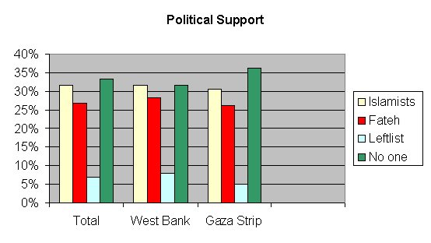

6. Attitudes towards freedom and equality

Palestinians support the principles of freedom of expression and equality before the law.

- 96% of the respondents said that the law should guarantee freedom of expression.
- 77% believe the law must guarantee the freedom to form political parties and the freedom to work.
- 77% support a legislative council based on proportional representation.
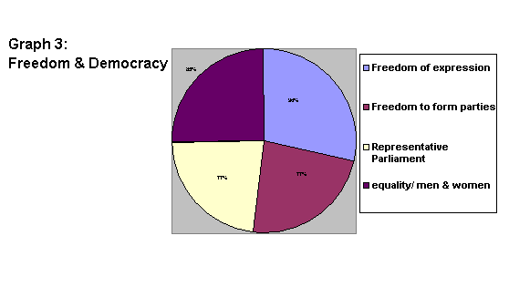

Top of this page | DSP Home

