Opinion Polls

Poll No. 12

Analysis of Results

[Analysis of Results] | [Detailed Results] | [PDF Format] | [باللغة العربية]

Background

- This poll was conducted under extreme conditions; roadblocks, curfews and invasions were the main characteristics. Living conditions continue to deteriorate, with higher poverty and unemployment rates recorded. The ongoing conflict with Israel resulted in escalated numbers of deaths and detainment during the period preceding and during polling.
- The war against Iraq has ended, with the United States and allied forces defeating Saddam Hussein’s regime. The sympathy of Palestinians towards the parallel plight of the Iraqi people (i.e., military occupation and deteriorating living conditions) has exacerbated existing negative feelings towards American foreign policy.
- Political dialogue within Palestinian society was measurably heightened over the last two months. Internal political processes and perceived external pressure have resulted in the inauguration of a new ministerial cabinet, headed by Mahmoud Abbas as its Prime Minister. While the new post is widely perceived to have been imposed on Palestinians by external forces, the Palestinian people feel strongly that this government should be given a fair opportunity to implement its plans.

Main Results

1. Further deterioration in living conditions

The results of the poll show that further deterioration in living conditions has taken place among Palestinians.

- 42% of the households have no working breadwinner.
- 15% have no income whatsoever.
- 25% of the households have a monthly income less than $160.
- In general, 79% of the households are poor (living below $380 per month; $1.9 per person per day for a family of 6.7 members)).

Deterioration in Palestinian living conditions
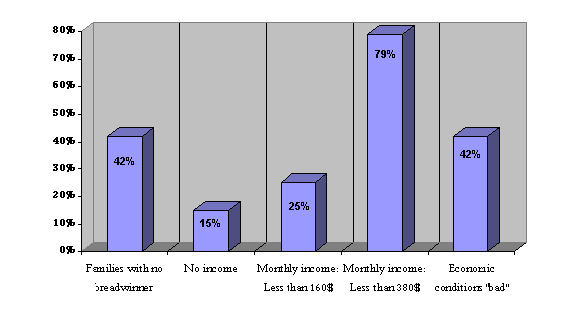
- 42% of the respondents described their economic conditions as (bad) or (very bad). In addition, 38% described their economic conditions as (fair). In contrast, only 20% describe their conditions as (good) or (very good). This perception of deteriorating household economic condition has been on the increase.

2. Lost sense of security

Most Palestinians have lost any sense of security as the results indicate:

- 61% feel insecure about themselves, their families and their property. In contrast, 20% feel secure.
- Regardless of this lost sense of security, most Palestinians are still hopeful for the future. About 44% say they are optimistic and 32% say they are pessimistic. In addition, 22% say they have mixed feelings.

3. Mixed feelings about the new government

Palestinians believe that the new government should be given a fair chance to succeed, but they also realize the challenges and understand the real constraints, leaving them with mixed feelings about future prospects.

- About 47% feel that the new government is serious in its intent to improve Palestinian living conditions. In comparison, 35% feel that it is not serious.
- The majority (51%) supports the confidence vote given to the new government by the Palestinian Legislative Council. In comparison, 33% oppose
- Respondents were divided on the government's platform (as proposed by the new Prime Minister). About 27% say that they support this platform, 39% say that they support it "to an extent", while 19% say they oppose it.
- Respondents were also divided on the question of representation. When asked if the new government best represents the interest of the Palestinians, 27% agreed and 36% disagreed. At the same time, 27% felt that the new government best represents the interest of Palestinians "to an extent".
- As to the competence of the members of the cabinet, 24% say that the members are "weak", 40% say that they are "fair", and 22% feel they are "good."
- If the new government is capable of achieving its goals, 26% feel that it is competent, 30% feel that it is "somewhat competent", while 32% feel that it is not competent.
- Still, respondents were somewhat optimistic when it came to specific objectives. When asked about the ability of the new government to resolve economic problems, 51% said that it would be able to do that. In addition, 50% said that it would be able to unify the work of security agencies. Over 60% said that the new government would be able to improve the performance of governmental institutions.
- Respondents were more cautious when it came to the issue of corruption; only 40% were optimistic that the new government would be able to resolve this problem, and 47% said that it would not be able to do that.
- While respondents have mixed feelings about the prospects of the new government, there was less division about the method through which the new government was appointed. A majority (52%) said that the process through which the new government was formed was "undemocratic". Another 20% felt that it was "somewhat democratic". Only 16% felt that the process was "democratic".
- In general, 27% support the platform (i.e., plan) of the new government, 19% oppose it, while 39% support it "to some extent."
- Finally, 34% were generally optimistic about the ability of the new government to improve living conditions, compared with 33% who were pessimistic.

4. Gaza - West Bank Variance

Gaza respondents were more hopeful and optimistic:
- 32% of Gaza respondents felt that the new government best represents the interests of the Palestinian people, compared with 23% among West Bank respondents.
- 51% of Gaza respondents believe that the new government is serious in its intentions, compared with 44% among West Bank respondents.
- 56% of Gaza respondents believe that the new government will be able to improve economic conditions, compared with 48% among West Bank respondents.

Attitudes towards new government

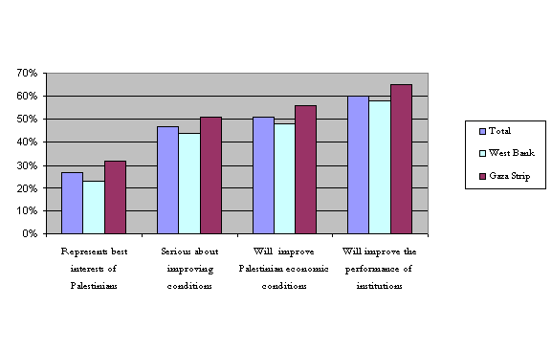

5. Priorities

Respondents felt that the top priority of the new government must be to force the Israeli army to withdraw from Palestinian cities. The second most important priority was the improvement of economic conditions, followed by eliminating corruption from Palestinian institutions.

Priorities expected of the new government
 | Total | West Bank | Gaza Strip
The withdrawal of Israeli forces from Palestinian cities | 59.2 | 61.8 | 54.5
Improving of economic conditions | 13.6 | 11.9 | 16.6
Rooting out corruption | 9.0 | 8.7 | 9.6
Reinforcing the rule of law | 4.1 | 3.5 | 5.2
Dealing with social chaos | 3.9 | 4.2 | 3.4
Continuing negotiations | 2.9 | 2.6 | 3.6
Conducting elections | 2.4 | 1.7 | 3.6
Improving the performance of institutions | 0.3 | 0.5 | 0.0
Others | 4.6 | 5.1 | 3.6

6. Internal Challenges to the New Government

- A majority (71%) support Abu Mazen's call to halt all attacks against Israeli civilians to provide a chance for negotiations. Support by 52% was conditional upon a halt to the Israeli military’s killing of Palestinians.
- In addition, 72% believe it is necessary that all Palestinians must give the new government a real chance to implement its programs; 20% feel otherwise.
- In contrast, 47% feel that Palestinian opposition groups will not give the new government a chance to implement its programs, while 38% feel that the opposition will.
- The vast majority (75%) support Abu Mazen's call for the centralization of authority and the end of the perceived chaos concerning national decision making. Abu Mazen said that all national decision making powers must be placed in the hands of one legitimate government approved by the legislative council.
- In terms of ending illegal possession of weapons, there was a split among the respondents, as 48% approve of Abu Mazen's call in this regard. In contrast, 46% opposed his call to collect all unlicensed weapons. This is due to a widespread feeling of insecurity caused by the ongoing conflict with Israel and its occupation of the Palestinian territories, as well a lack of confidence that the Palestinian Authority will be able to defend Palestinians from Israeli military attacks. It is also due to fears that attempts to force opposition groups to surrender their weapons might result in internal Palestinian fighting.

7. External Challenges

Respondents feel that the new government will face external obstacles, especially those placed by Israel and the United States.

- 58% feel that the Israeli government will actively work to cause the new government to fail.
- 45% feel the United States will do the same. However, 47% feel that the United States will not be an obstacle to the success of this government.
- 73% think that Israel will not implement the Road map, 17% disagree.
- In addition, 56% believe that the United States is not serious about its calls o implement the Road Map, 31% believe that it is serious.
8. Support for Negotiations

Increasingly Palestinians are supportive of the resumption of negotiations with Israel. The appointment of the new government (led by Abu Mazen) might be one factor explaining this increase.

- A majority (63%) supports the resumption of negotiations with Israel. Support has dramatically increased from 52% in February 2003. Support for negotiations is higher in the West Bank (66%) than in Gaza (58%).

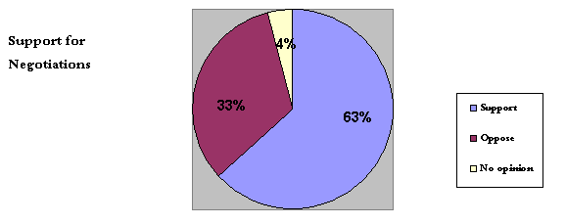

- Concerning the (Road Map), respondents were evenly split on this issue. One third opposed it, 24% supported it to (some extent), and 30% supported it.

Top of this page | DSP Home

